**LORA SENSOR NODE**

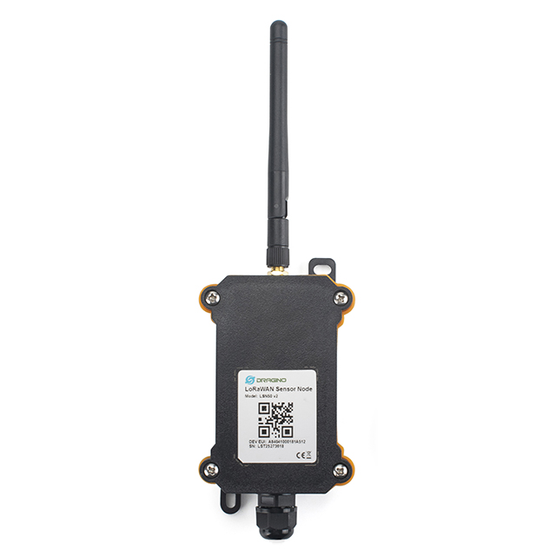 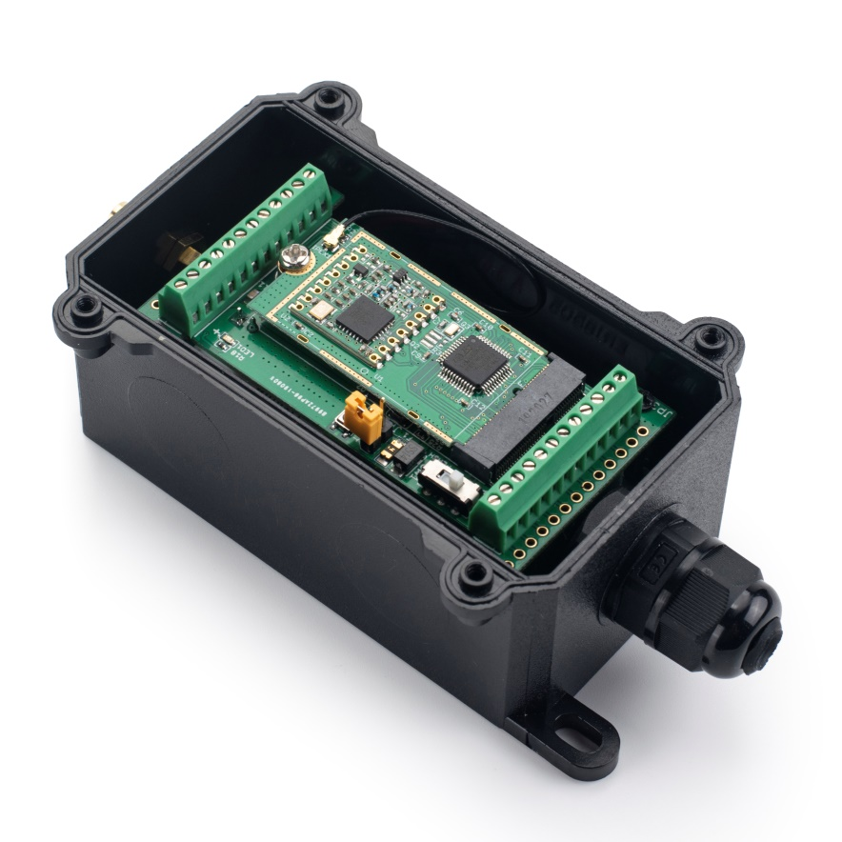

**Description**

LSN50 LoRa Sensor Node is a Long Range LoRa Sensor Node. It is designed for outdoor use and powered by Li/SOCl2 battery for long term use.LSN50 is designed to facilitate developers to quickly deploy industrial level LoRa and IoT solutions. It help users to turn the idea into a practical application and make the Internet of Things a reality. It is easy to program, create and connect your things everywhere.

LSN50 wireless part is based on SX1276/SX1278 allows the user to send data and reach extremely long ranges at low data-rates. It provides ultra-long range spread spectrum communication and high interference immunity whilst minimizing current consumption. It targets professional wireless sensor network applications such as irrigation systems, smart metering, smart cities, smartphone detection, building automation, and so on.

LSN50 MCU part uses STM32l0x chip from ST, STML0x is the ultra-low-power STM32L072xx microcontrollers incorporate the connectivity power of the universal serial bus (USB 2.0 crystal-less) with the high-performance ARM® Cortex®-M0+ 32-bit RISC core operating at a 32 MHz frequency, a memory protection unit (MPU), high-speed embedded memories (192 Kbytes of Flash program memory, 6 Kbytes of data EEPROM and 20 Kbytes of RAM) plus an extensive range of

enhanced I/Os and peripherals.

LSN50 is an open source product, it is based on the STM32Cube HAL drivers and lots of libraries can be found in ST site for rapid development.

## **LoRa Specification**

* 168 dB maximum link budget.
* +20 dBm - 100 mW constant RF output vs.
* +14 dBm high efficiency PA.
* Programmable bit rate up to 300 kbps.
* High sensitivity: down to -148 dBm.
* Bullet-proof front end: IIP3 = -12.5 dBm.
* Excellent blocking immunity.
* Low RX current of 10.3 mA, 200 nA register retention.
* Fully integrated synthesizer with a resolution of 61 Hz.
* FSK, GFSK, MSK, GMSK, LoRaTM and OOK modulation.
* Built-in bit synchronizer for clock recovery.
* Preamble detection.
* 127 dB Dynamic Range RSSI.
* Automatic RF Sense and CAD with ultra-fast AFC.
* Packet engine up to 256 bytes with CRC.
* Antenna: External

**MCU Specification**

* MCU: STM32L072CZT6
* Flash:192KB
* SRAM:20KB
* EEPROM:6KB
* Clock Speed: 32Mhz

**Absolute Maximum Ratings**

* VCC: 0.5v ~ 3.9v
* Operating Tempature: -40 ~ 85°C
* I/O pins: 0.5v ~ VCC+0.5V

**Common DC Characteristics**

* Supply Voltage: 1.8v ~ 3.6v
* Operating Tempature: -40 ~ 85°C
* I/O pins: Refer STM32L072CZT6 datasheet

**Power Consumption**

* STOP Mode: 2.7μA @ 3.3v
* RX Mode: 7.2mA
* TX Mode: 125mA@ 20dbm

**Battery**

* Li/SOCI2 non re-chargeable battery
* Capacity: 4000mAh
* Self-Discharge: <1% / Year @ 25°C
* Max continuously current: 130mA
* Max boost current: 2A, 1 second